GITHUB 2: Essentials

A brief example of how Github works, and how you will use it too!

- A programmer makes some changes to their files: In the photo you see that I’ve added the material for the first lecture.

  - Github will tell me which files were added, which ones were edited, and which ones were removed.
  - A batch of changes is called a “Commit”. I will give it a self-explanatory name. “Add material for the first lecture”.
  - I click on the button “Commit to main”

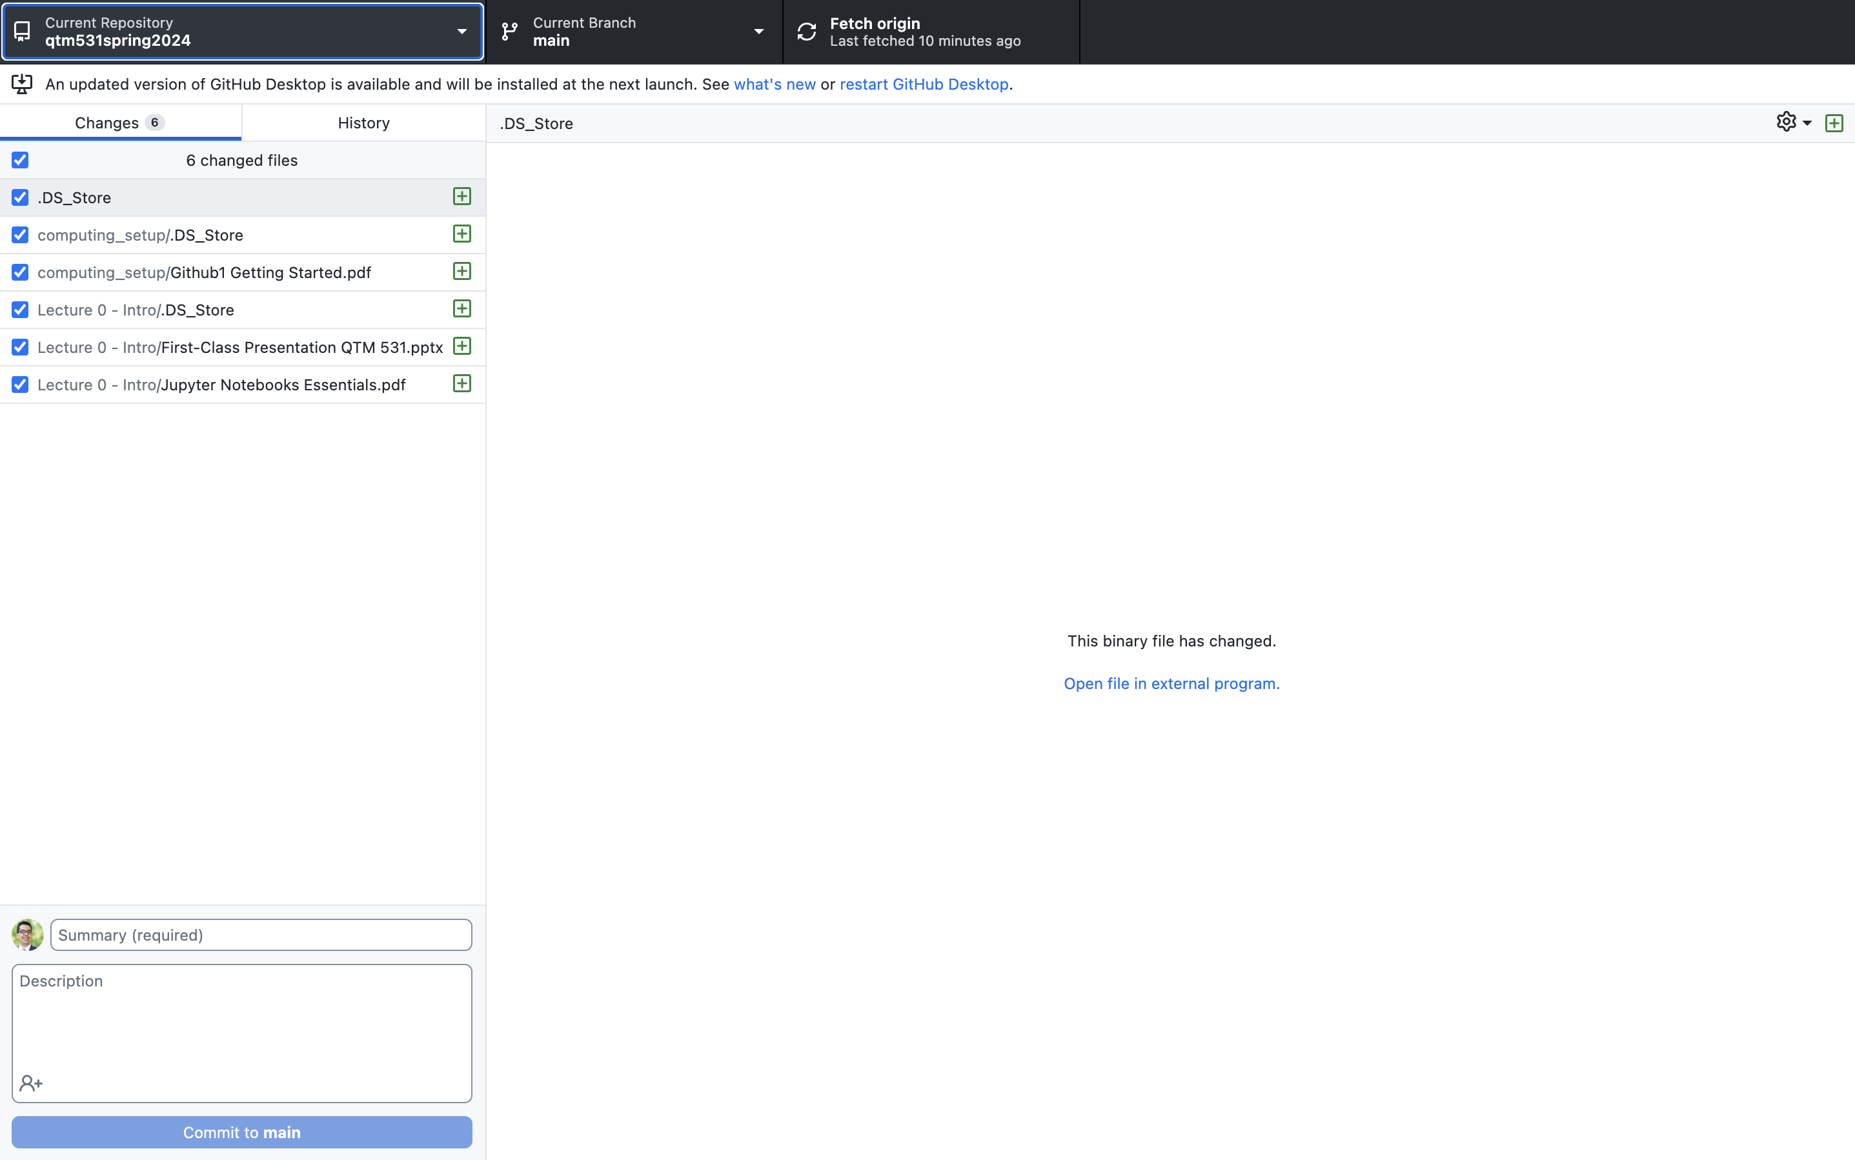

It’s good to balance making commits frequently (so that your code stays up-to-date) and organizing your commits logically. This makes it easier to communicate with a team what you’ve done!

- After you’ve committed your changes, you can go the “History” tab. This will show you a list of all the commits that were made in the past, who made them, and what changes were made.
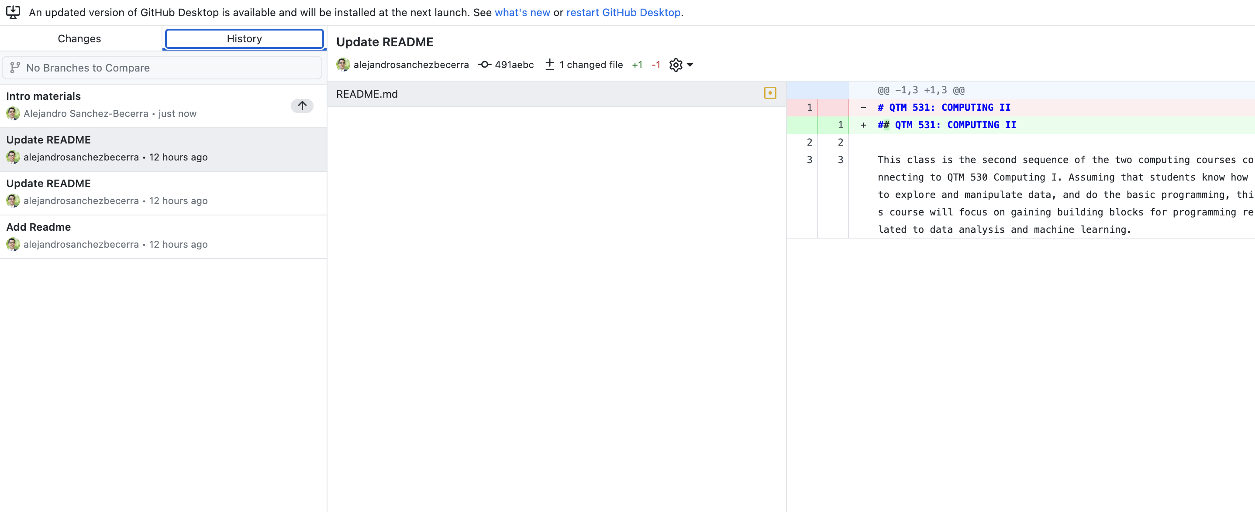
When your local repository has an online Github version (called origin here), you will see two types of options to synchronize your files with the cloud:



- This is for “fetching” material from the cloud.

- This is for “pushing” material to the cloud. This option appears when you’ve saved new commits and haven’t yet uploaded them to the web (like in the case I present in the previous example).
- When you click on Push origin, it will save all the local changes into the online Github repository.

For general information on Github:

https://docs.github.com/en/get-started

Sometimes you can have different versions of the same folder/repository. The primary one is always called “main”.

